Competition Scrapbook

The Guts Smokehouse Competition BBQ Team has racked up over 50 Top Ten finishes in professional BBQ competitions. Contained below are incredible moments captured in time from each of our competitions ... enjoy!

- - - - - - - - - - - - - - - - - - - - - - - - - - - - - - - - - - - - -

NEW HOLLAND, PA - August 2013 (71 teams)

2nd Place - Chicken (near Perfect Score)

3rd Place - OVERALL!

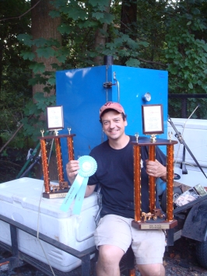
Lots of hardware for Guts Smokehouse BBQ team!

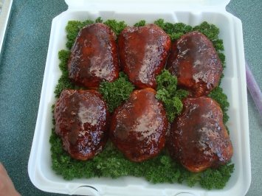
Near perfect chicken ... score of 177.7 ... WOW!

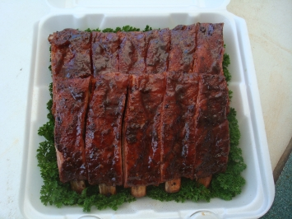
Gorgeous ribs.

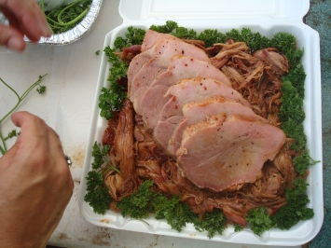
Atkins muscle of picnic came out awesome!

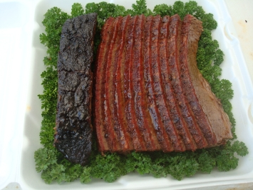
Brisket ... right on the money!

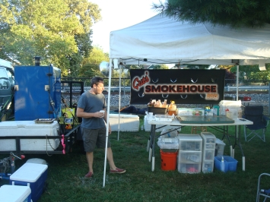
Morning shot of the pit area.

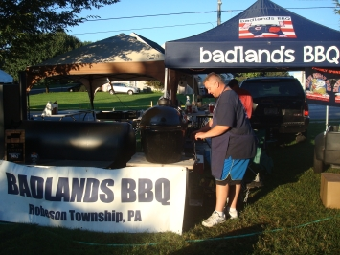
Our buddies from Badlands BB ... pit boss Bart!

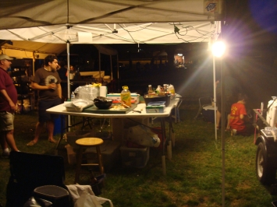
Friday night with Mike and Chris.

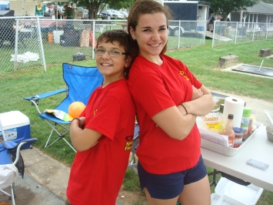
Awesome shot of bro and sis.

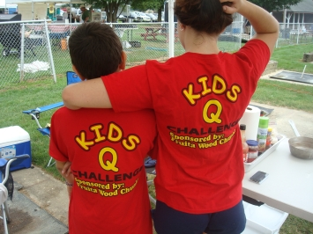
Cool Kids Q shirts

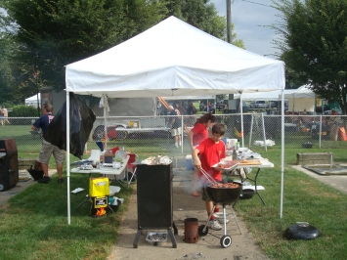
Kids working hard.

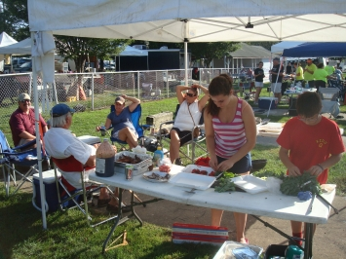
Kids focusing on tasks at hand.

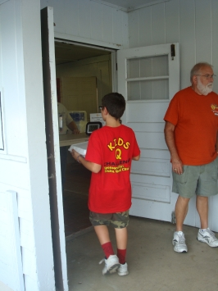
Jake's final turnin of the day.

CHESAPEAKE, VA - May 2012 (46 teams)

3rd Place - Pork

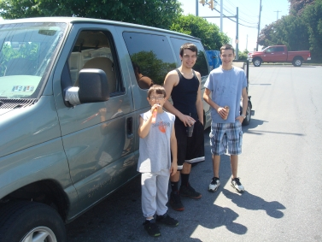
Pitstop at Wawa on the way down with the men.

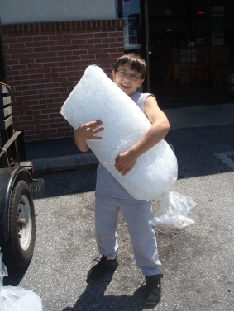
Jake hoising up a 40 lb bag of ice all by himself.

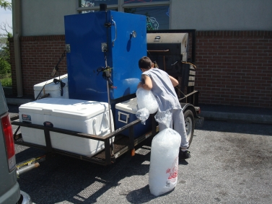
Final icing for safe storage of the $300+ of food to be taken to the bbq competition ... a small fortune.

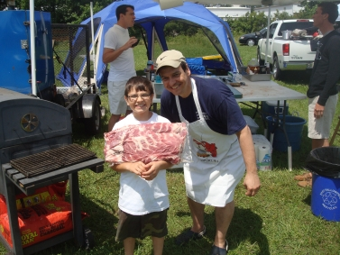
Free Smithfield ribs handed out at the competition. Jake will cook these ribs for us.

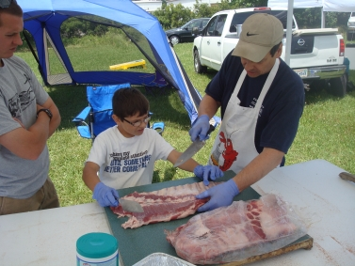
Precise trimming of ribs is required for maximum taste and scoring.

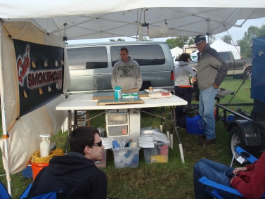
Evening festivities about to begin under the big top.

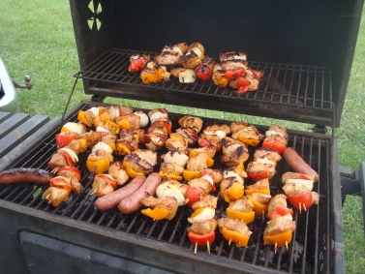
Guts Smokehouse BBQ cooks up dinner for Pigs On the Run thanking them for sponsoring us at the competition.

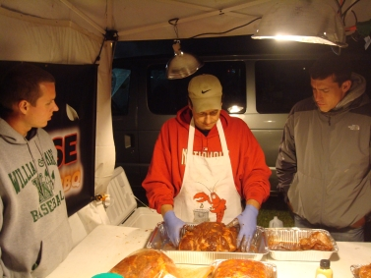
FInal prep of pork butt that would eventually place 3rd overall and only 1/2 point shy of a VA State Championship.

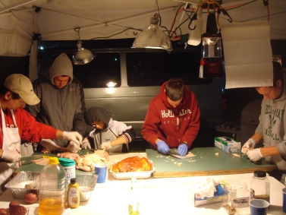
The pergatory of competition ... chicken skin scraping, and nobody does it better or faster than Nate.

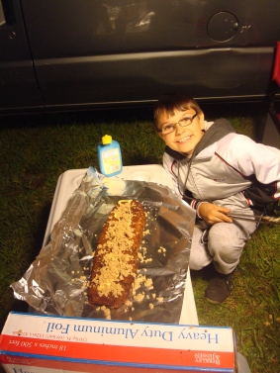
Jake wrapping his Smithfield ribs ... my do they look good.

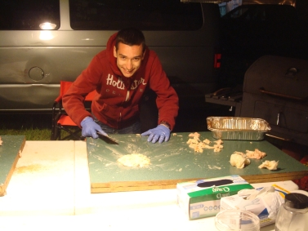
Pergatory is over, the skins scraping is complete ... big thanks and shout out to Nate!

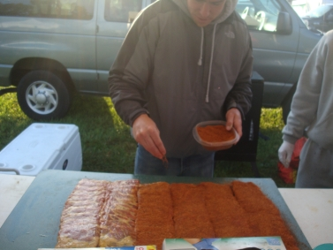
Jeffrey seasoning the ribs with Guts Rub ... they came out delicious.

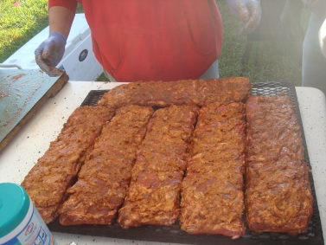
Bacon butter ... myth or reality ... still not sure ... but hey, bacon on anything is never a bad thing.

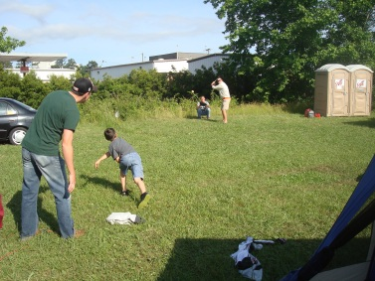
Some relaxation time as our future major leaguer warms up.

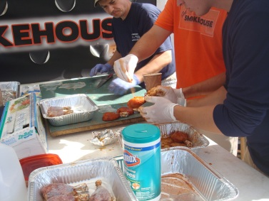
Trying something new with the chicken legs ... looked incredible but did not get a call for it.

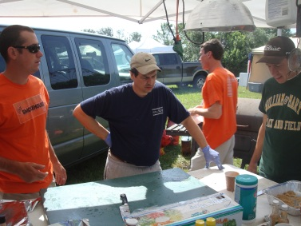
As always ... the Pit Boss is FOCUSED!

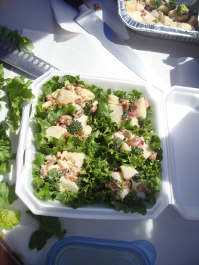
The Hedley and Clark phenominal potato salad entry ... an attempt to win $10,000.

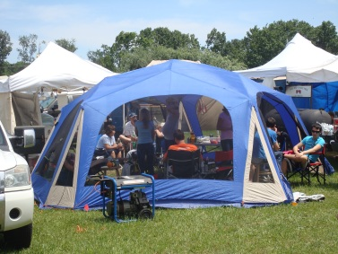
Again, a great sprawling setup.

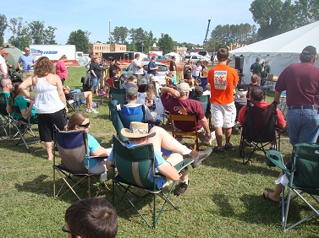
It's the Awards Ceremony ... the most gut wrenching part of any competition.

NEW HOLLAND, PA - Aug 2011 (72 teams)

4th Place - Brisket
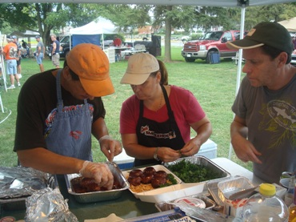
Chicken Box prep ... experimentation with Myron's Muffin Pan chicken. It came out gorgeous. While it did Jake well, it did not impress the certified judges.

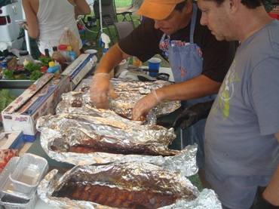
Here come the ribs ... ew la la !

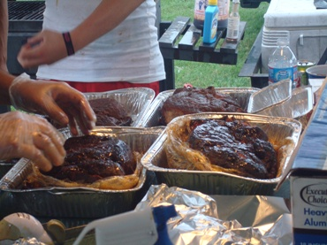
Butts are ready for boxing ... dang they came out good!

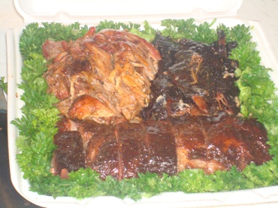
Pork box ... some of the best bark we have ever done!

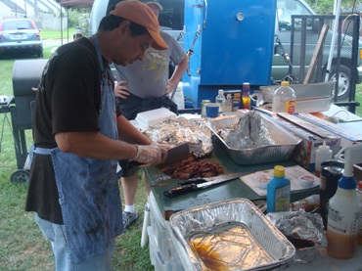
Chopped brisket in the making. Jennifer makes thee absolute best chopped brisket on the planet. A key to our brisket success!

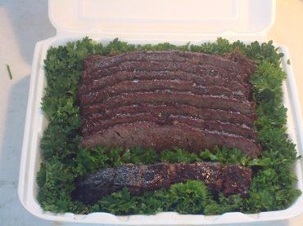
An award winning 4th place brisket box ... out of 68 teams.

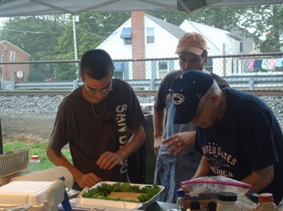
Nate's Smoked Salmon Chef's Choice dish. It was moist and lucsiouos, and the judges thought the same. We got this dish in just in time before the furry of Hurricane Irene hit.

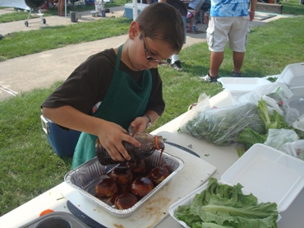
Jakey 'Bakey' Guttman finishing his muffin pan chicken with the homemade blackberry sauce. One of the judges, a certified KCBS judge, commented that it was some of the best chicken she had ever tasted in 10 years of judging. Those are some powerful words of encouragement for this up and coming ten year old BBQ chef.

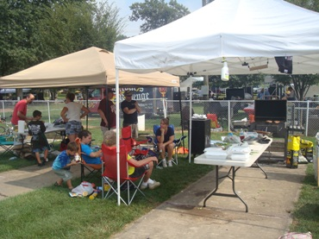
The kids pit area ... it has almost all the ammenities as the big boys pit area.

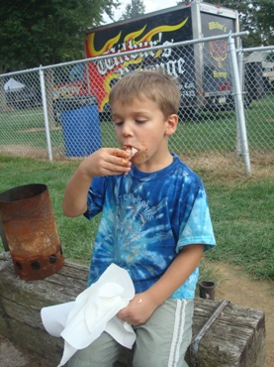
Max sampling Sarah's scrumptious chicken wings ... bones and all.

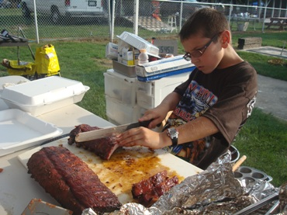
Precision slicing of Jake's 1st place Ribs. Chuck Sheffield, who runs the whole BBQ event, stated in front of a large crowd that these were the best ribs he ever tasted as a judge and that this included his judging of the professional teams. Wow ... maybe someday Jake will be a National Rib winner!

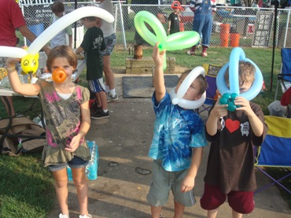
Fun times at the kids pit with the clown ...

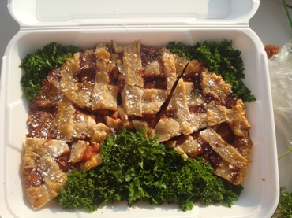
Sarah's made-from-scratch Strawberry Rhubarb pie. She actually baked this pie over charcoal. This was an amazing feat.

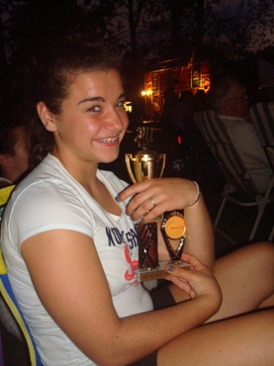
Sarah's cuddling with her hard earned, and well deserved, trophy.

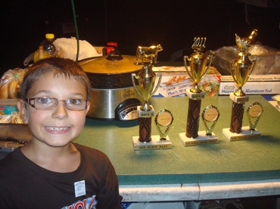
Jake's hardware display ... 1st in Chef's Choice (Ribs), 2nd in Chicken, and 3rd in Beef.

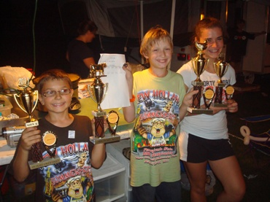
Jake next to long-time friend and pit master Sammy Vink, last year's Kids 2010 Grand Champion ... and sister Sarah ... many congrats to all! Keep up the hard work for next year.

CHESAPEAKE, VA - May 2011 (48 teams)

1st Place - Brisket (STATE CHAMPION)

8th Place - Pork

7th Place - OVERALL
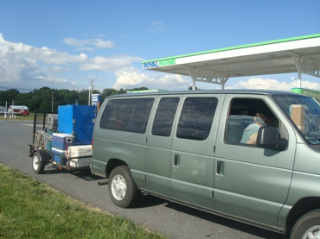
Pit stop at Royal Farms on Route 13 on the way down to the Jubilee! Oh to have this moment back knowing what lie ahead. The soon to be State Champion BRISKET is buried safely in the big white cooler.

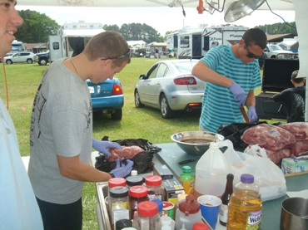
Jeff Lunardi and Stephen Hedley prepping a pork shoulder butt.

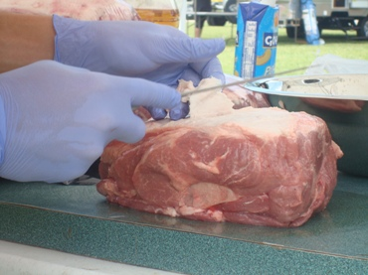
Slicing fat off the pork butt thereby allowing for the ultimate bark to form.

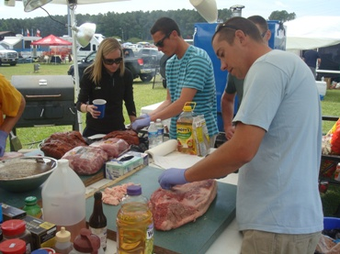
The gang preppin meats in the early morning hours.

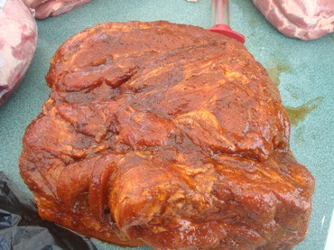
Butt ready for the marination tank.

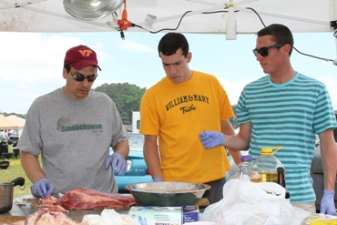
Well someone has got to inject this thing ... how about you?

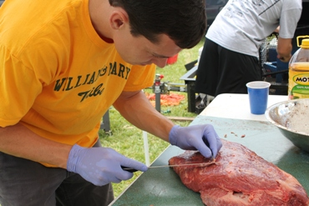
Dr. Hedley performing surgery on 'THEE' Brisket (a.k.a. the 'terd')

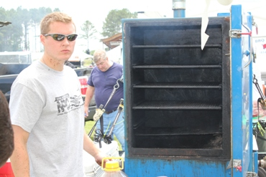
Jeff Lunardi thinking he can replace Mike Rowe in 'Dirty Jobs'.

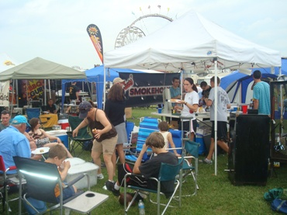
The Friday afternoon tailgate in full swing ...

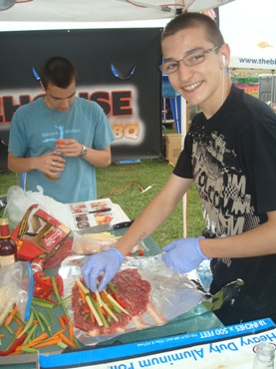
Nate's yummy pinwheel flank steak for Chef's Choice

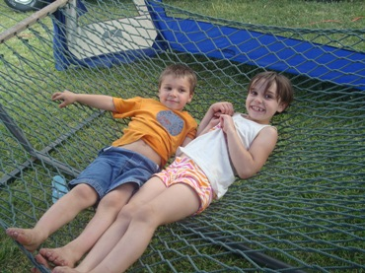
In the words of Max ... "Livin like Larry!"

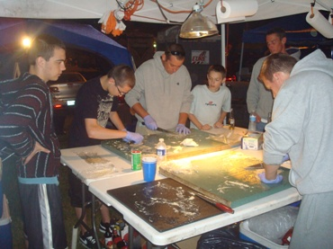
Midnight pennance ... chicken skin scraping.

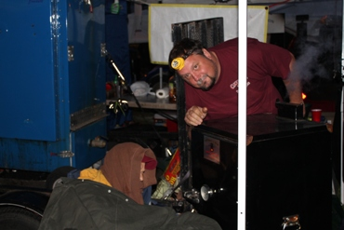
John "The Miner" Atkins ... wanting so bad to be part of the Guts Smokehouse BBQ crew.

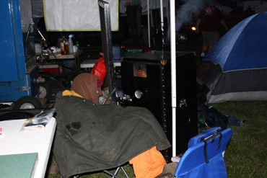
When you become part of the Guts Smokehouse BBQ crew, you too can sleep in a luxurios wardrobe, with the finest of life's ammenities, each night at a competition.

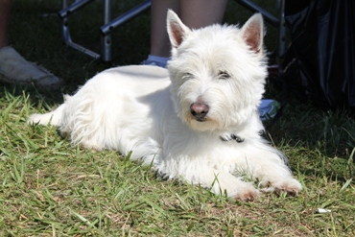
Now really, do I look like the kind of dog that would pee on a competitors prep table?

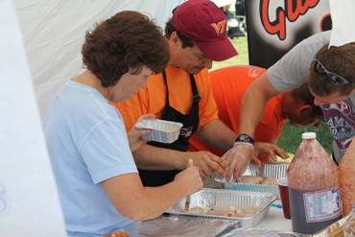
Duck fat pleeeeeeeeeeeease ...

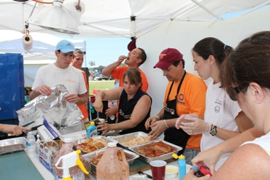
All hands on deck ... it takes a village to win a competition.

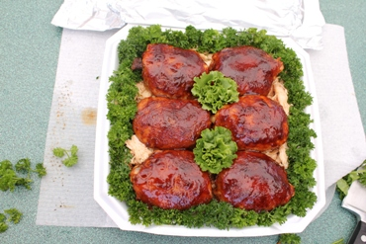
Beautiful Chicken Box ... what were those judges thinking!

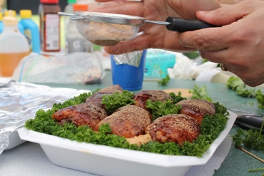
Final dusting of the chicken.

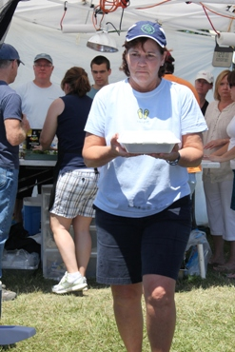
Lyn off to her first turn-in ... you go girl!

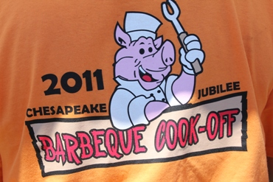
One of the coolest comp shirts ever handed out.

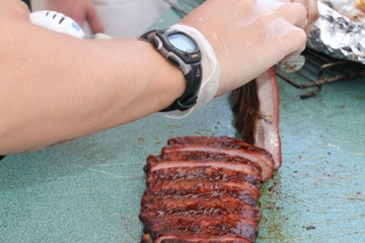
Selecting the right ribs.

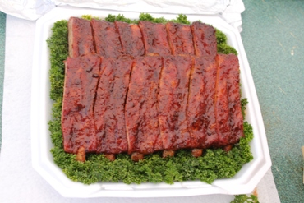
Our ribs for the day, not quite up to par ...

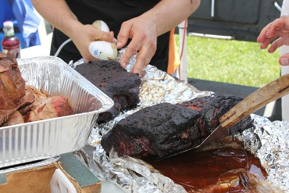
Butt's are a beautiful thing!

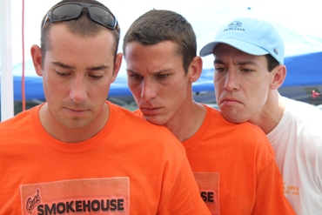
Larry, Moe and Curly ... a.k.a Matt, Stephen and Jeffrey

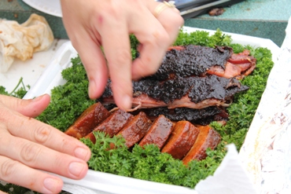
Look at the bark on that butt ...

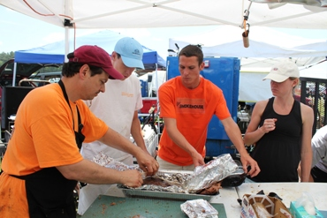
The unveiling of the 'terd' (secret name for the USDA 'Select' quality brisket)

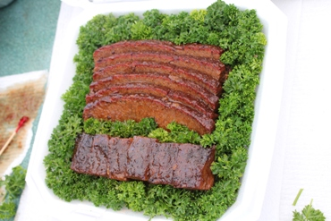
Championship Brisket at its finest.

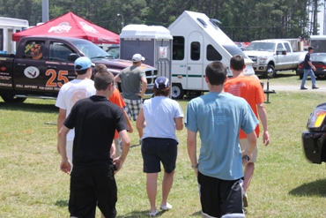
The gang is off to the final turn-in of the day.

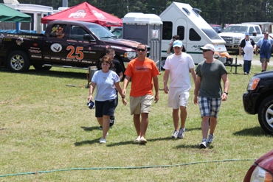
Whew ... it is all over ... the security guards can rest easy for another year.

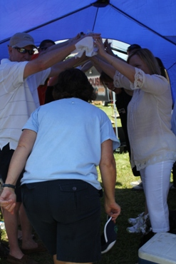
Lyn walking through the celebratory tunnel after the final turn in of the day. There is no more a celebrated 'runner' than our very own Nellie.

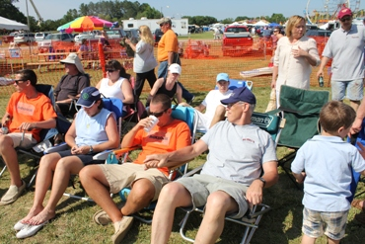
A huge family following awaits the Awards ceremony.

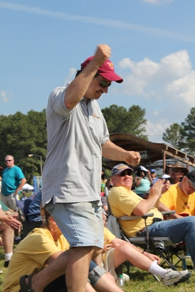
The "Fist of Victory" as the 1st Place Brisket announcement is made.

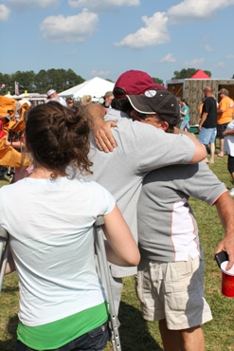
Bret from The BBQ Guru congratulating us after the Awards ceremony. We got to know these guys back in 2008 at the Dover Downs competition and have been friends ever since.

Nel and Guts enjoying the moment.

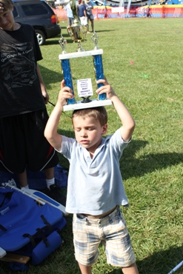
Max holding up the 1st Place Brisket trophy ... this photo immediately made it to Facebook to tell the world who the 2011 Virginia State Brisket Champions were.

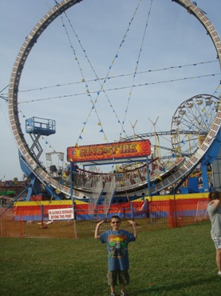
Jake proudly 'holding up' the Ring of Fire which he went on and lived to tell about. Couldn't pay me enough to go on that thing!

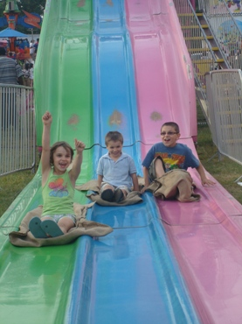
One of the best photographs of the Jubilee. You want to talk about capturing a moment-in-time. The three little ones having fun on the Big Slide. The kickoff to summer just does not get any better than this! Love those haircuts!

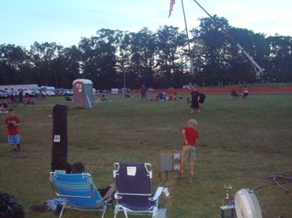
This picture may not look like much to most but it captures a moment in time that generates many emotions for me. It was dusk ... We had just won a Virginia State BRISKET Championship (trophy in foreground) ... Everyone was slowly returning from the carnival rides and games ... The kids were tossing football ... There was great anticipation for the start of the best fireworks on the East Coast ... The 10,000 Maniacs were playing live to one of my favorite in-the-moment songs ever called 'These Are The Days' ... Summer was knocking on the door ... Oh, and the world did not come to an end at 6:30 PM on this the 21st day of May, 2011. The picture was taken intentionally because of these reasons. I wanted to capture a visual of the exact moment. Even our private porta-potty in the distance played a role in the flurry of weekend memories. Long live the Chesapeake Jubilee 2011.

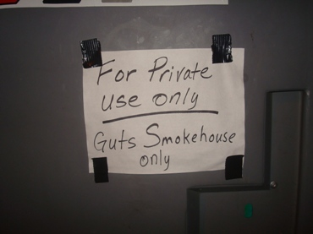
Keep away all you common'ers, this is Guts Smokehouse BBQ's "private" porta-potty, and we have the key to prove it!

NEW HOLLAND, PA - Aug 2010 (72 teams)

2nd Place - Ribs

9th Place - Brisket

5th Place - OVERALL
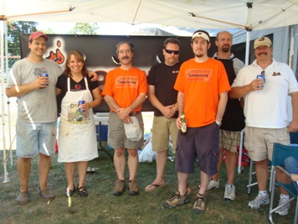
Award winning Pit Crew ... from right to left (Mike Guttman, Pete Vink, Chris Patton, Harold Morris, Craig Patton, Jennifer and John Guttman)

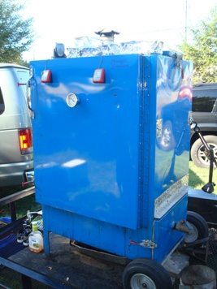
Big Blue cranking away on its 33rd hour ...

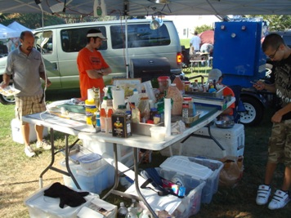
Morning Prep at the pit ...

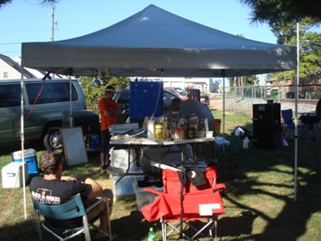
Morning Prep at the pit ...

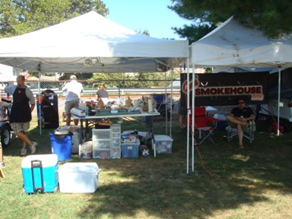
Morning Prep at the pit ...

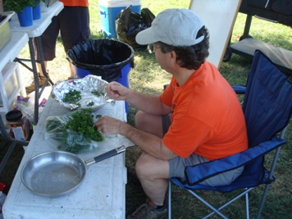
Craig painstakingly pulling parsley tips for box presentation.

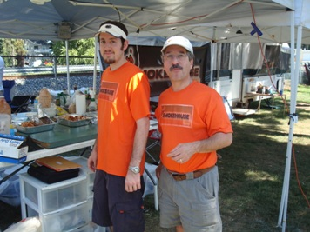
Father and son combination prove critical for the success of the day ...

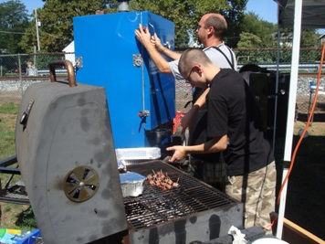
Nate making the Chef's Choice dish of Prosciutto wrapped Figs with a Red Wine Balsamic syrup ...

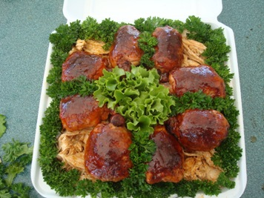
Chicken Box ready for the judges ...

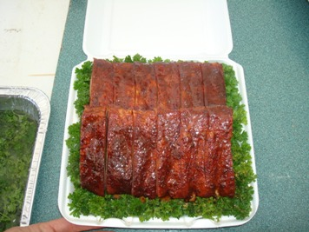
Rib Box ready for the judges ...

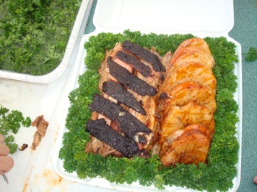
Pork Box ready for the judges ...

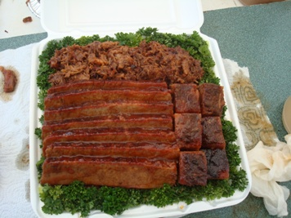
Brisket Box ready for the judges ...

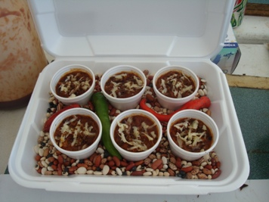
Killer Brisket Chili box ready for the judges ...

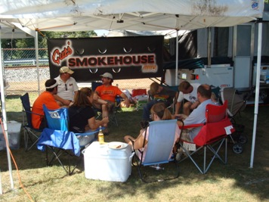
The team and family chillin out after a long greuling two days of hard work ... awaiting the Awards Ceremony.

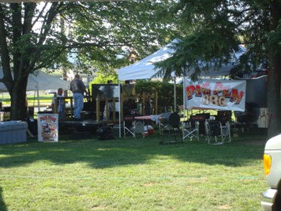
One of our first and best friends on the circuit ... Rich from Pig Pen barbecue ... an expert Whole Hog cooker!

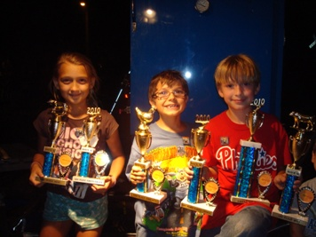
The kids of the pit crew dominating the Kids Q bringing home 6 pieces of hardware ... Sammy taking home the Grand Champion of the 10-and-under group.

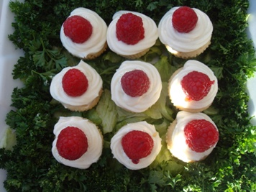
Sarah's dessert was worthy to be on the front cover of Bon Appetit magazine ...

DOVER, DE - Oct 2009 (81 teams)

5th Place - Pork

9th Place - OVERALL

HARRISBURG, PA - Oct 2009 (20 teams)

8th Place - OVERALL

NEW HOLLAND, PA - Aug 2009 (72 teams)

4th Place - Pork

8th Place - Chicken

4th Place - OVERALL

CHESAPEAKE, VA - May 2009 (35 teams)

4th Place - Brisket

7th Place - Chicken

10th Place - Ribs

5th Place - OVERALL
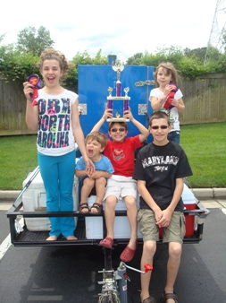
This is what it is all about ... family and BBQ! The future of Guts Smokehouse BBQ proudly displays more hardware and software from the team's 4 top ten finishes to start the 2009 competition season.

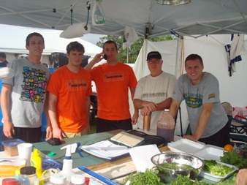
The Virginia Beach connection pit crew. This awesome bunch of guys, with equally supporting ladies, is the reason the team keeps rising closer and closer to the top at the Jubilee.

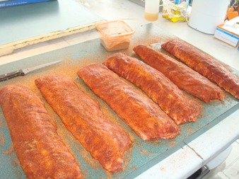
Beautiful, organic, pork baby back ribs ... rubbed down with a little Guts Rub love. Pork sashimi anyone?

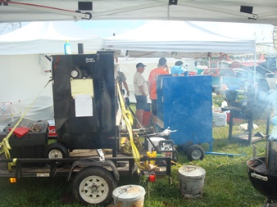
Stumps versus Stumps. Pigs on the Run smoker (foreground) and Guts Smokehouse BBQ smoker (background) go head to head at this year's competition. Pigs on the Run have been friends and mentors for several years, and are a key reason for the success of our team.

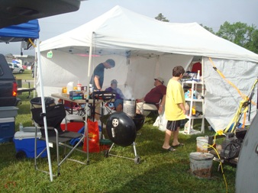
Here are our Pigs on the Run buddies/neighbors. Just like us, they had a full squad, but it was only John's brother Ricky that would stay up all night tending their smoker, and keeping us company as well.

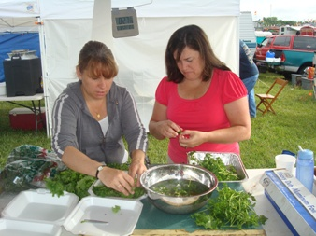
It's Saturday morning and the presentation experts are busy prepping the greens for the boxes. Not a small task as it takes hours to get it just right.

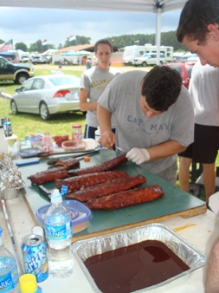
Guts checking the doneness of each rack of ribs making sure only the best get sent to the judges. The ribs we cooked during our test run the night before were some of the best ribs ever, however, competition day is another story as crunch time is a lot more tense.

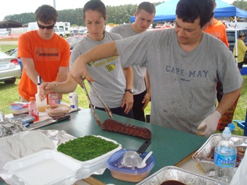
What a gorgeous rack of baby backs, all ready to be laid on a beautiful bed of greens that took almost and hour and a half to prepare.

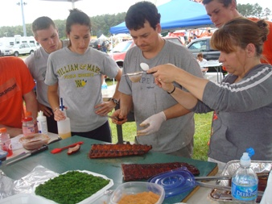
A final dusting of Guts and Guns powder gets applied to the ribs before being sent off. Every detail is critical at this level and making sure each rib is seasoned properly is very, very important.

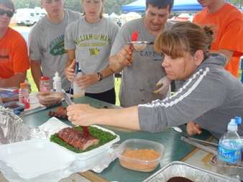
Jenn making sure that every rib is perfectly positioned. Presentation can be the difference between 1st and 5th place.

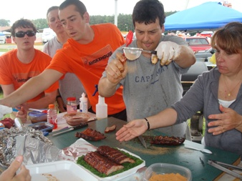
The final presentation of the ribs. All ready to go off to the judges.

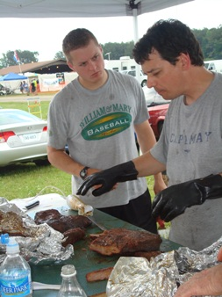
Jeff and Guts doing some initial checkout of one of the four beef briskets smoked for competition. This is the most difficult of all the meats to cook properly at a competition. Diet, excercise and the type of cattle can make a difference between 10 or 14 hours of smoking.

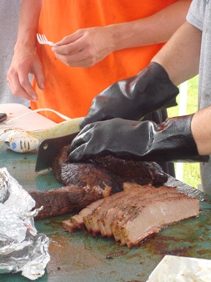
Some nice slices coming off this brisket flat. These may be 'box' worthy.

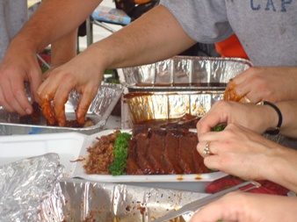
The brisket box being assembled.

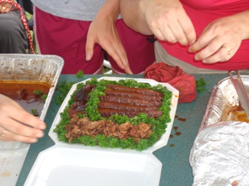
The final touches being added to the brisket box. Every spec of the surface is scrutinized before the box is closed and our runner takes it to the judges. Out of the three areas you are judged in, presentation is the only one you have total control over. Its got to be done right! Remember the old cliche ... you eat with your eyes first.

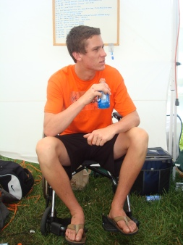
Stephen Hedley takes a breather, which he sure earned by pulling an all-nighter. His tenacity was a key factor in our success this year. I just hope we get to taste his 'Trenchtown Chicken' dish at next years competition!

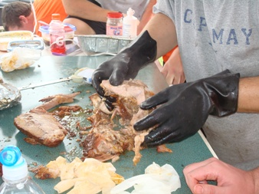
The pork shoulder is being pulled and tested for taste and tenderness.

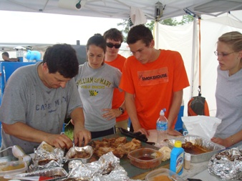
The team looks on as more pork gets pulled and tested. It pays to have a lot of dreuling pit crew members, except for the fact that at this point anything tastes great!

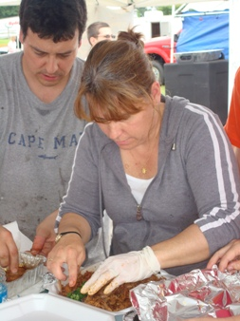
Again Jenn and Guts begin the box assembly.

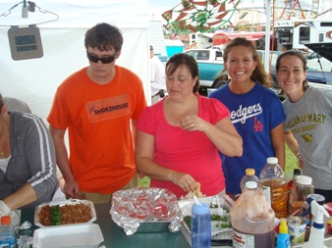
Kimberly, Morgan and Linda (from right to left) pose for a quick smile. Patrick is not allowed to smile until turn in's are over ... :-)

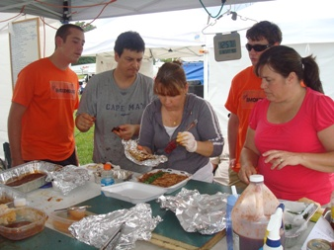
The paint brush comes out to coat the pork during the final moments of prep.

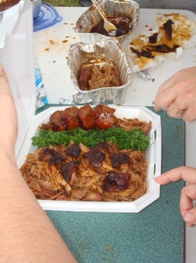
The pork box is just about compete with pulled, bark and medallions.

Lots of hands involved in getting things where they need to be. Everyone worked so well together.

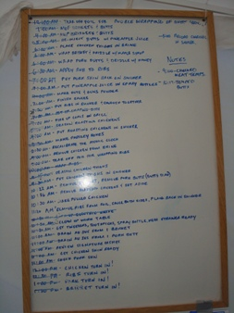
Now this is a project schedule! Mess up one thing and you might as well pack up and go home.

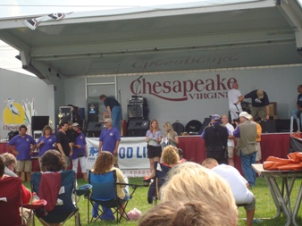
Guts (holding daughter Tessa) graciously accepting an award on behalf of the BBQ team.

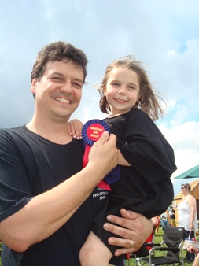
A proud moment for daddy and daughter as they display some software!

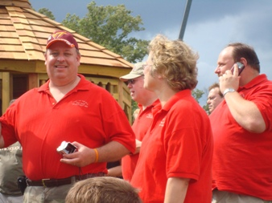
Our good friends, the Pigs on the Run BBQ team, hanging out with us at the awards. Maybe someday our team will be able to afford cool shirts like that.

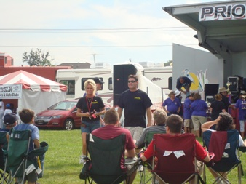
And congrats goes to the Wood Chicks BBQ team for winning it all. Even though we beat them in two of the four categories, their overall scores were higher than ours. But hey, finishing that close behind a team that has been on the Food Network competing against Bobbly Flay isn't all that bad.

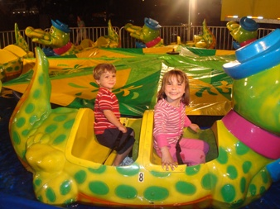
Post competition festivities as Tessa and Max take on some rides.

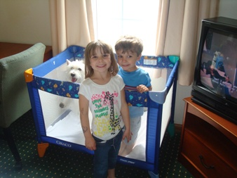
Tessa and Max (oh, and Buffett) pose for one of the final shots of the trip at the hotel.

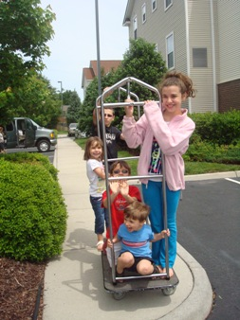
The Jamaican Bob Sled team practicing for the 2020 Olympics.

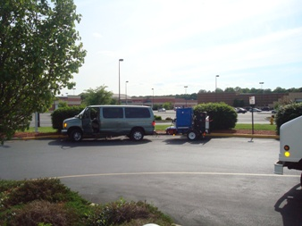
Here we are parked outside of our traditional stop at the mid-way point home, the Wawa in Salisbury. Only 3 hours left until we reach our destination.

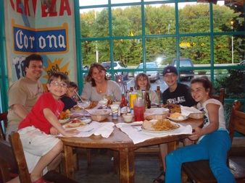
An impromptu stop at our favorite Tex-Mex restaurant, the Border Cafe, on Route 7. A final celebration of Jenn's 40th birthday as well as a great memory from this year's four top ten finishes at the Chesapeake Jubilee competition.

DOVER, DE - October 2008 (78 teams)

6th Place - Brisket

7th Place - Ribs

9th Place - OVERALL
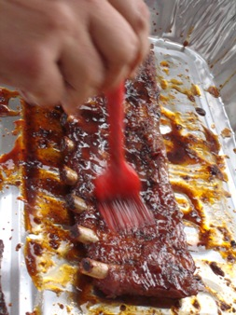
Brushing the finishing sauce onto the perfectly cooked spare ribs. These ribs would help give the team their 7th place finish in this category out of 78 teams.

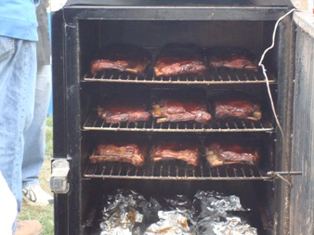
Here are 15 racks of spare ribs smoking away in the Backwoods 'Rib Machine' smoker. This smoker turns out phenominal ribs.

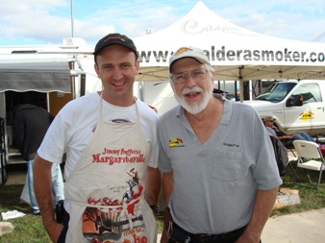
Pete with BBQ legend 'Shotgun' Fred, also known as the "BBQ Guru". Someone please pour that man a shot of tequila.

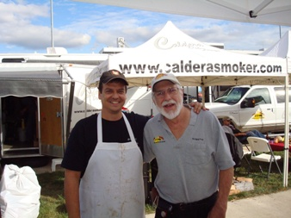
Guts with BBQ legend 'Shotgun' Fred, also known as the "BBQ Guru". It was a pleasure getting to know this icon of the barbecue circuit. We were in some good company with Fred to our side and Tuffy, from Cool Smoke, right behind us.

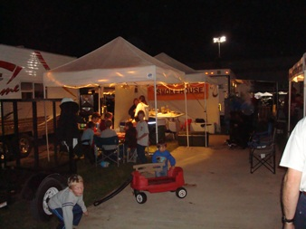
Ahhh ... night sets as the Friday night party gets underway. We smoked a 16.5 pound turkey all day long that we had for dinner, along with baked beans, pasta salad and homemade corn muffins from Sarag G.

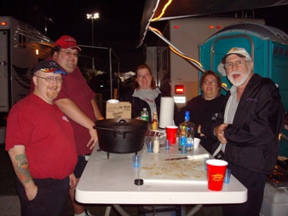
Friends Redd and Tiny gather around the 'guru' for some Friday evening chatter. Redd made some phenominal "Chicken and Bones" soup ... boy can that guy make a soup or what!

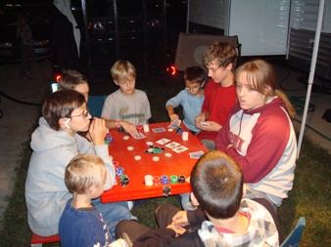
The Friday evening poker game commences amongst the kids. It would continue late into the night.

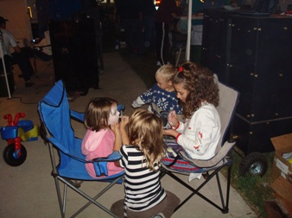
Line dancing and face painting entertained the girls as they danced to the music of our good neighbors all night long.

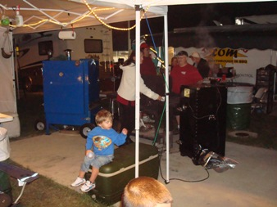
Max "the Moose" chillin out on the cooler during the Friday evening festivities.

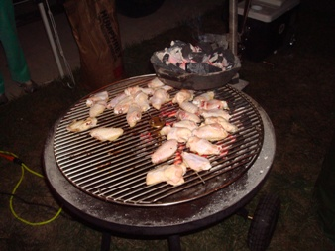
The next invention-prototype from Fred, a grill that cooks from the top and bottom at 700 degrees fahrenheit.

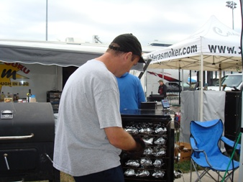
Pete closely guarding that smoker full of comfort food ... some would give their right arm to have what is in there ... that being lots of juicy ribs!

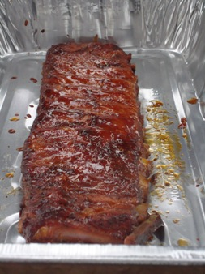
Last year we had the 'perfect storm', this year we had the 'perfect slab'.

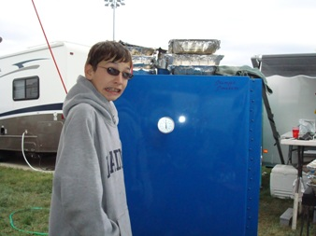
Nate being silly next to Big Blue.

NEW HOLLAND, PA - August 2008 (72 teams)

4th Place - Brisket

9th Place - Ribs

6th Place - OVERALL
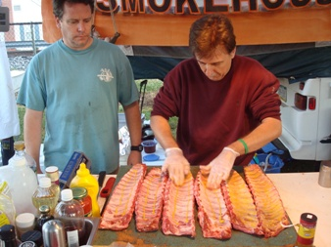
Nick Conti giving the spare ribs a rub down while Harold Morris supervises the process. Little did they know but six of those ribs would prove to be a 9th place finish out of 72 well seasoned teams ... and only a point away from 6th place!

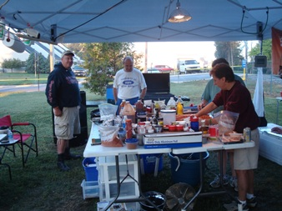
Dream pit crew ... including senior crew member Pete Vink, foodies Nick Conti and Harold Morris, along with pit crew 'Rookie of the Year' Jeff Lunardi, and Mark Harris from Bubba's BBQ and member of Pigs On The Run Championship BBQ Team.

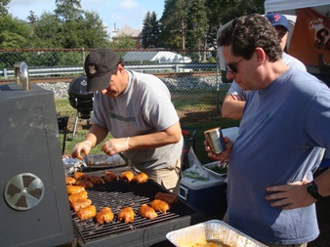
The chicken is near finished as Guts and Harold apply the finishing touches. Although the chicken was some of the best ever, it did not place in the top ten. What were those judges thinking.

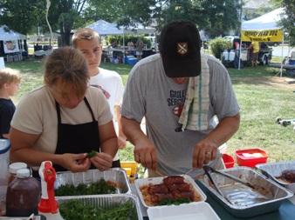
Once again the tandom of Jenn and John putting together the chicken box. We love our life!

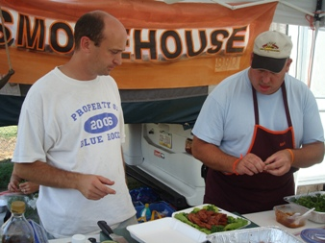
Pete and Mark putting together the sausage box.

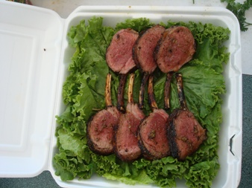
Awesome Lamb dish a'la Vink ... good enough for an 11th place finish!

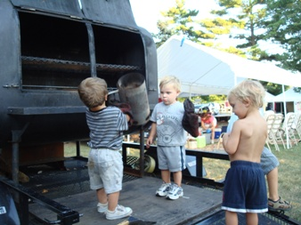
The future of Guts Smokehouse! Instinctively they already know what's going on ... yikes!

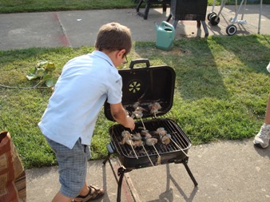
Jake working hard on his grill at the Kids Q. This dish is Sambvuca Shrimp wrapped in Prosciutto.

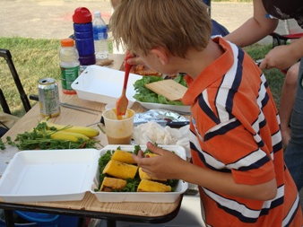
Sammy applying his final sauce to his grilled plantains. This dish was 11 months and 30 days in the making.

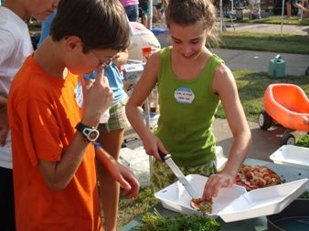
The cheeesecake survives a terrible crash and is being served up to the judges. Sarah is so relieved as she happily serves up a slice.

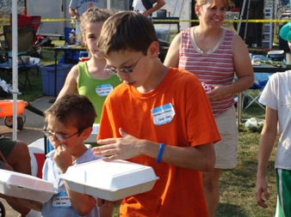
Nate with a finished box as the family looks on.

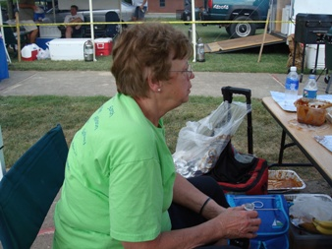
Grammy Helen, one of near 50 supporters that showed up, taking in all the action.

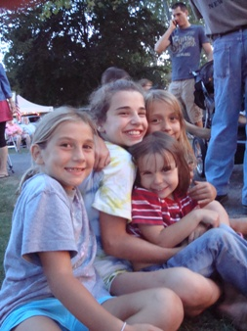
The girls anxiously awaiting the Kids Q award announcements.

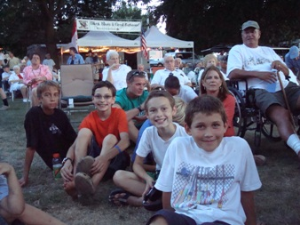
The boys anxiously awaiting the Kids Q award announcements.

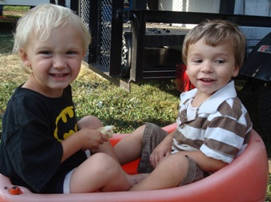
Daniel and Max riding in the trophy mobile.

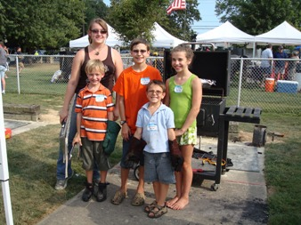
The Kids Q competition was filled with hometown entries. Sarah and Sammy Vink along with Nathan, Sarah and Jake Guttman. A lot of hard work and sweat went into their efforts which sure produced some fantastic food!

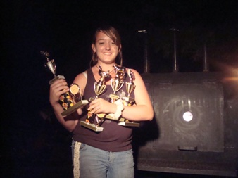
16 year old Sarah Vink, daughter of senior pit crew member Pete, bringing home mucho hardware in every category possible ... Beef, Chicken, Chef's Choice and Overall. Not too bad for this first time competitor. To think what next year will bring for this rising culinary star!

LEESPORT, PA - July 2008 (22 teams)

1st Place - Brisket

5th Place - Chicken

6th Place - Pork Shoulder

3rd Place - OVERALL
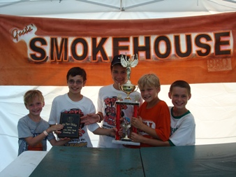
The junior pit crew proudly displaying the 1st place brisket trophy. These guys flawlessly ran the smoker throughout the night until 6:00 AM the next day. They were a big part of the days winnings. From left to right we have Sammy Vink, Nathan Guttman, Patrick Quinn, Andrew Vink, and Michael Quinn. Missing from the photo in Peter Vink Jr.

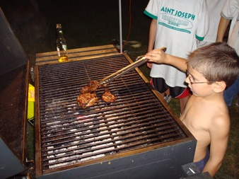
Jake grilling up some rib tip appetizers for the pit crew members.

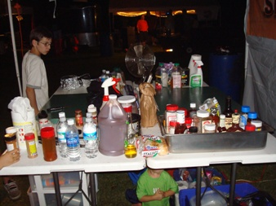
The pit area loaded for bear with more seasonings, spices, sauces, rubs, marinades, mops than you can shake a stick at. Believe it or not they all have a specific purpose.

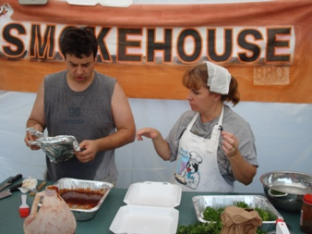
Jenn and John working the pit during hand-in. The temps were 110 degrees under the canopy and it sure shows in this shot.

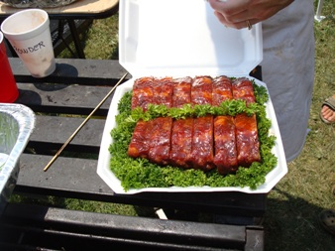
A baby back rib sampler all ready for hand-in to the judges.

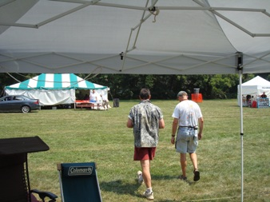
Pit crew members Kevin and Pete making the first run of the day ... Chicken. Once again they make it with only 47 seconds to spare. Linda Mullane, the KCBS rep, is yelling at them to hurry up. Pete was scene scampering along at Linda's command. When Linda says hurry ... you hurry, even if you're Pete! The turn-in was good enough for a 5th place plaque.

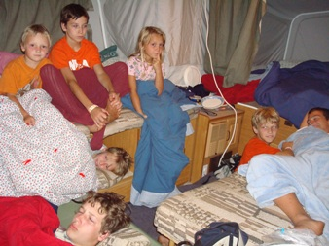
Here is the pit crew family members scattered and snuggled in the camper. It is amazing the lengths these dedicated youngsters will go through for the team.

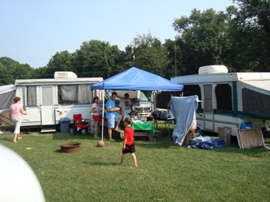
This was the Guts Smokehouse BBQ headquarters during the competition where the families hung out while the men slaved over a hot smoker for almost 18 hours ... and loving it!

CHESAPEAKE, VA - May 2008 (29 teams)

3rd Place - Pork Shoulder

6th Place - Chicken
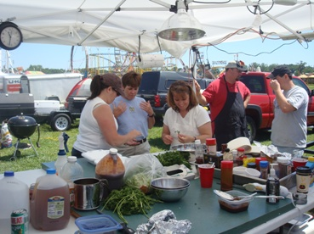
Linda, Lyn and Jenn getting the greens ready for presentation. Pigs on the Run pit master John Atkins and Guts chewin some fat in the background just 30 minutes before the first hand-in.

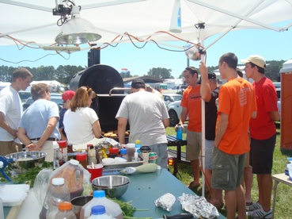
A tense pit crew looks on as the final work on the chicken is being performed. The chicken would be turned in with only 6 seconds to spare. A close call, but a worthy one, as it took 6th place honors. This was the teams first top ten finish in chicken.

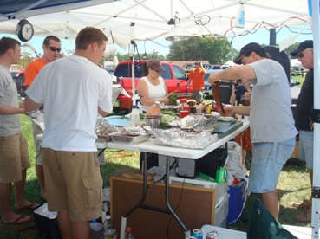
The first slab of lucious ribs comes out for inspection. Jeff, Patrick, Matt and Chris look on with great anticipation.

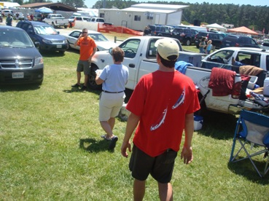
Nel Evlyn Hedley (a.k.a. Aunt Lyn) running the rib box to the judges station. She is heavily guarded by sons Matt and Jeffrey. The protection beefed up as the hand-in's continued. No one was going to mess up Lyn's run to the judges station.

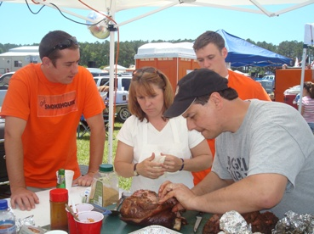
Guts looking for some good bark on this nicely cooked pork shoulder, which ended up taking 3rd place honors. Jenn is not quite sure if this is the one to use.

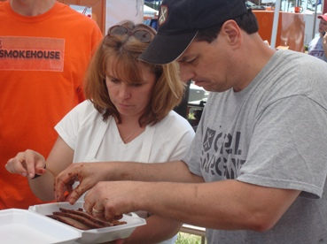
Jenn and John begin loading the brisket box. Little did they know at the time, but they were a few tweaks (and weeks) away from a top prized brisket.

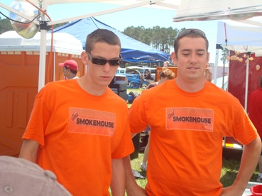
Hedley brothers Stephen and Matt proudly displaying their team shirts as another dish is prepped for hand-in to the judges.

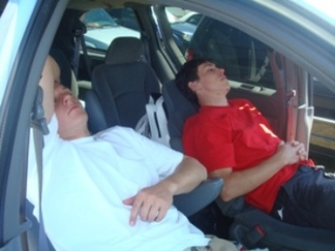
This is what a professional barbecue cook-off will do to even the young 'stallions' of today. Or are they just Virginia Beach whimps? Just kidding, you guys were absolutely awesome!

DOVER, DE - Oct 2007 (83 teams)

3rd Place - Pork Shoulder

5th Place - Beef Brisket

9th Place - Overall
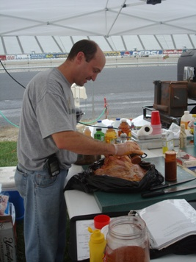
Pete cleaning the absolute last brisket to be found in Dover, Delaware ... an 18 lb. beauty ... which by the way would end up finishing in 5th place out of 83 seasoned teams including 5 of the top 30 in the country. Our brisket even placed ahead of the top brisket team in the country, iQue.

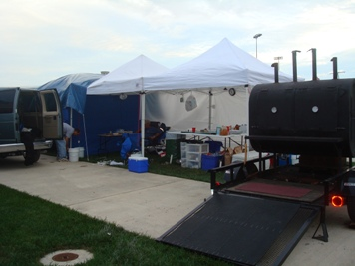
Setup is complete, and is nice and cozy ... until ... 11:18 PM ...

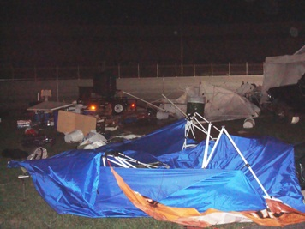
The micro burst hit hard and all that was left standing at the pit was the smoker ... Old #99. Winds were guestimated at 75+ mph, which by the way are Hurricane Category 1 level winds. All three EZ Ups were lost within seconds of the blast. Thankfully, no one was injured ... traumatized YES, but injured NO. Thanks go out to the random folks that came by to help us pick up all of our scattered belongings ... you guys are great!

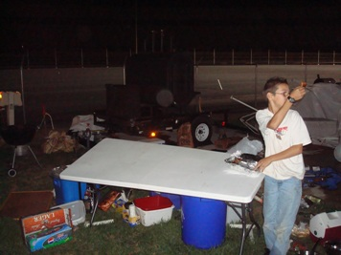
...Nathan excited about finding something ... a sign of hope ...

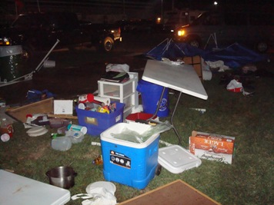
hey, has anyone seen our stuff?

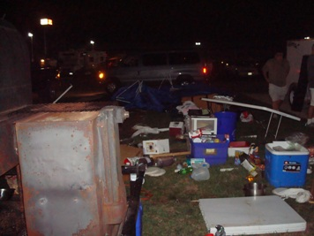
In total honesty, we came real close to just packing up and going home. But we somehow got the fan working to help fuel the firebox. So, at 1:30 AM we set up a table with absolutely no protection from the elements, gathered some essentials, and got back to business!

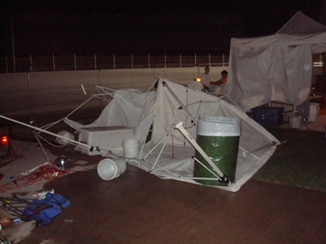
A mangled mess of aluminum ... some good recycling money sitting there.

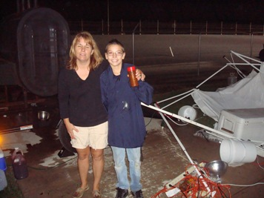
A disgruntled Jenn, and a relieved "I'm just glad to be alive" Nate...

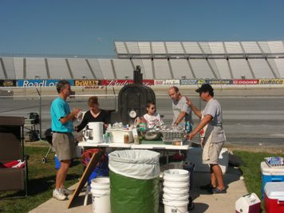
Bare bones setup ... recovery from the storm leaves but a table and a smoker ... which apparently was all we really needed.

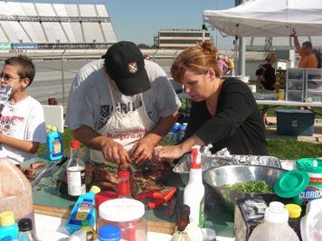
Guts and Jenn focused on picking the perfect parts of the shoulder for hand-in ... it DOES NOT get any more intense than this!

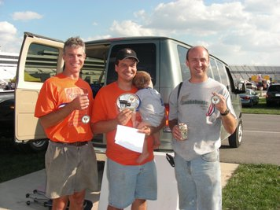
The team's tenacity produces a 3rd, 5th and 9th place finish ... what an incredbile memory.

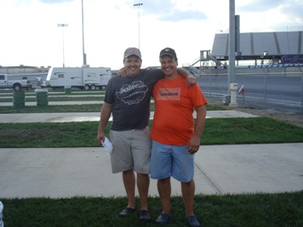
Guts with neighbor, and new friend Chris, from the nationally acclaimed iQue barbecue team ... Go SOX!

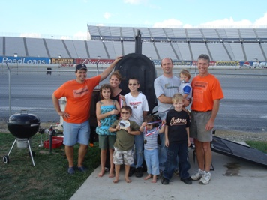
The gang in front of the tank!

NEW HOLLAND, PA - Aug 2007 (72 teams)

2nd Place - Pork Shoulder
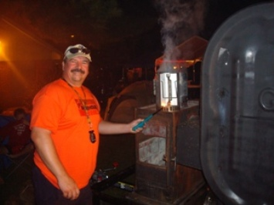
Guts big brother Mikey Beast, the team's "pork injector specialist" with the inaugural light of the smoker on Friday night...

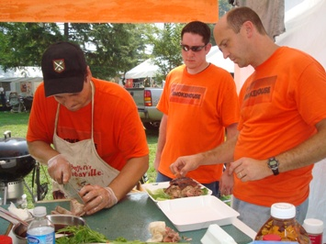
Guts and team preppin up what would eventually turn out to be award winning Pork Shoulder...

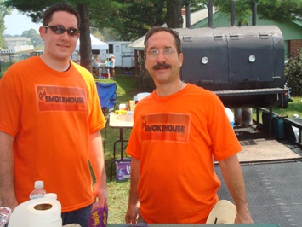
Awesome pit crew members Christopher and Craig ... thanks so much for the hard work guys, you made the difference!

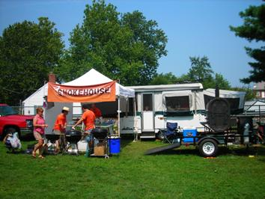
Pit Area with new team banner ... compliments of Susan and Sarah Vink ... you guys are awesome!

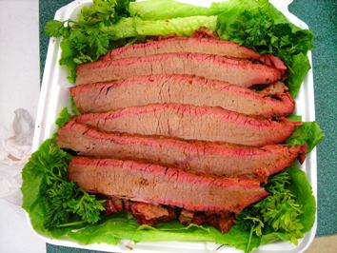
Look at that perfectly cooked beef brisket ...

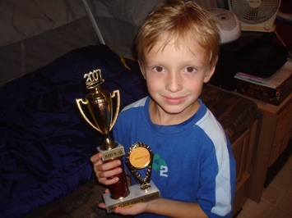
Sammy Vink bringing home some hardware in Chef's Choice for 10-and-under ...

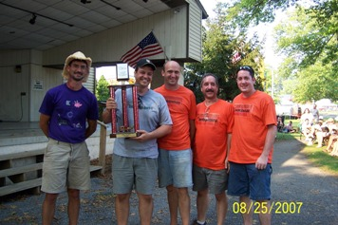
The Guts Smokehouse BBQ Team graciously accepting their 2nd place honors in Pork Shoulder ... they also want to congratulate the Lost Nation Smoke Company for their repeat 1st place win in this category!

CHESAPEAKE, VA - May 2007 (28 teams)

10th Place - Pork Ribs
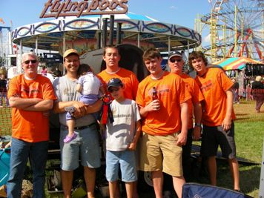
Guts Smokehouse pit crew proudly holding their first ribbon ... a 10th place finish in Ribs!

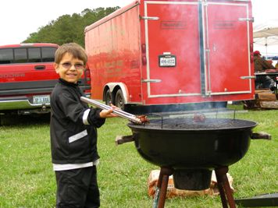
Handsome Jake working the kettle grill...

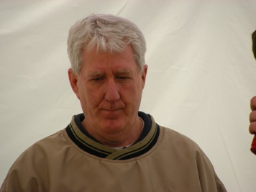
Pit crew member Ned Clark pondering a major team decision...

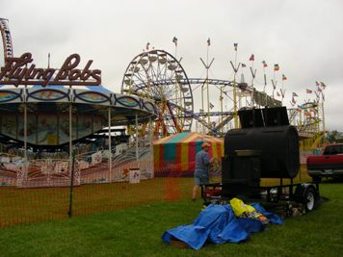
Pit area setup only yards from the world famous 'Flying Bobs' ride at the carnival...

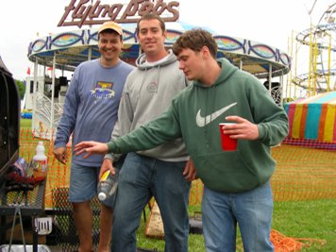
Guts, Matt and Pat relax and enjoy the Friday prep time together...

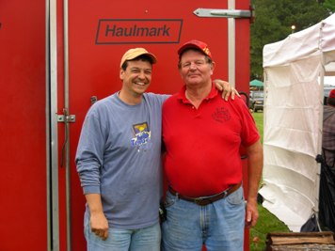
Guts with George from 3 P's Cooking Team. What a treat to meet an old sauce like this. And his wife's cooking, oh my ... that chili sure hit the spot on that damp day ...

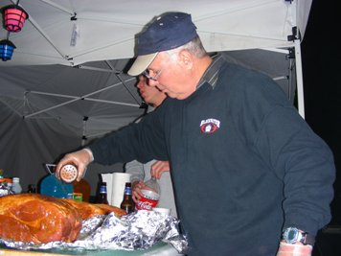
Chris putting the finishing touches on the pork butt's just before they enter the smoker...

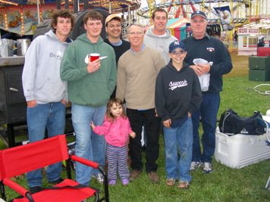
The pit crew hanging out in front of the smoker getting all warmed up...

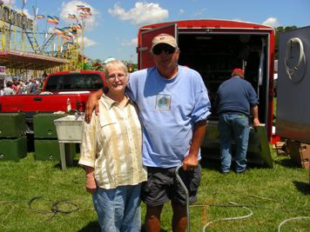
A family reunion at the competition as Dave (aka. Gramps) and sister Dawn get together at the cook-off...

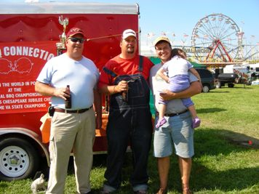
Guts pictured with new friends John and Mark from 'Pigs on the Run' ... the team that finished 5th in the World in Pork Shoulder at the 2006 World Series of BBQ, the American Royal...

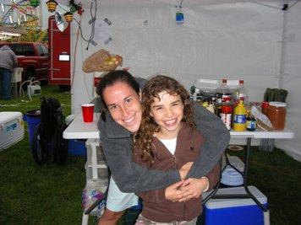
Kimberly and Sarah sharing a snuggly moment together...

SALISBURY, MD - April 2007 (46 teams)

15th Place - Special Perdue Chicken category
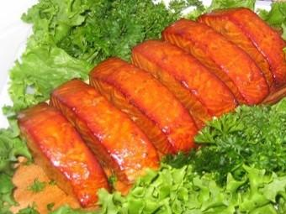
Chef's Choice - Cedar/Apple/Whiskey smoked salmon...

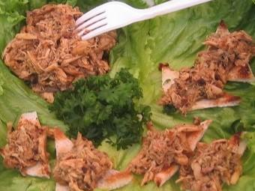
Pulled Chicken - 15th best in Maryland for the special Perdue category...

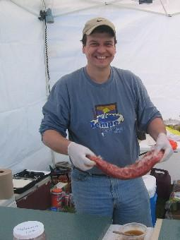
The Boss preppin some loin ribs...

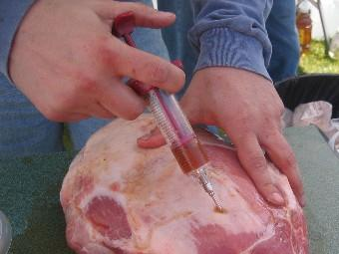
Pork Butt gets injected...

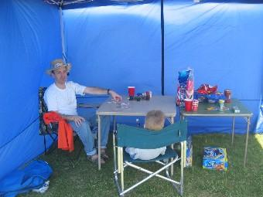
Island Pete chillin' with son Sammy for a little poker...

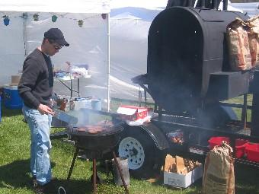
Greg workin' the grill making lunch for all ...

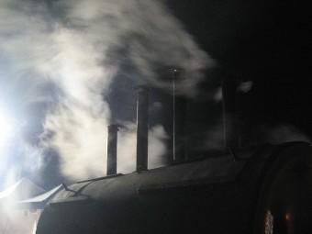
Old #99 crankin' away at 2:30 AM...

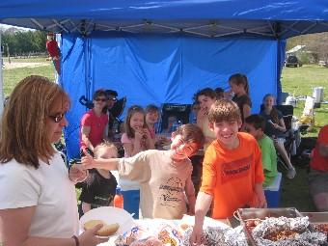
The gang reaping the benefits from the all night smoke-a-thon...

NEW HOLLAND, PA - Aug 2006 (72 teams)

22nd Place - Chicken
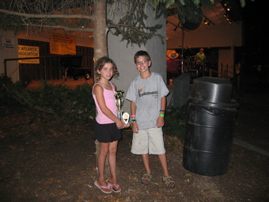
Sarah and Nathan display their trophy for finishing 2nd place in beef for "Kids 10 and under" in Pennsylvania, 2006! You can view the video here!...

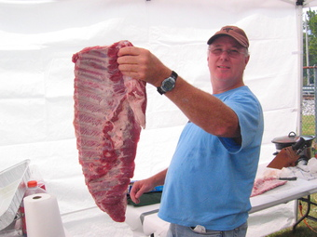
A slab to remember at New Holland Summerfest 2006...

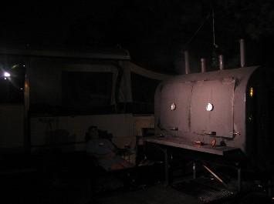
3:00 AM ... and all is oh so well ...

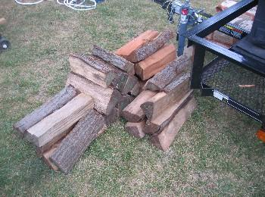
Hickory, Oak, Cherry and Maple ... let the competition begin ...

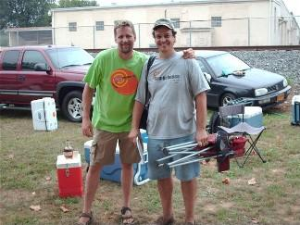
Guts with Chris Capell from the famous Dizzy Pig Barbecue Company ...

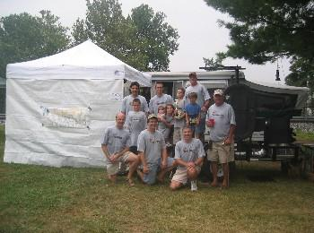
2006 Guts Smokehouse BBQ Team (with supporting family) ...

